CS 255 System Design Document
Alec Brandt

UML Diagrams

UML Use Case Diagram… | … See Figure 1 (pg. 3)
UML Activity Diagrams… | … See Figure 2-1,2-2 (pg. 3)
UML Sequence Diagram… | … See Figure 3 (pg. 4)
UML Class Diagram… | … See Figure 4 (pg. 5)

Technical Requirements
Hardware Requirements
• Client devices: Standard desktop computers, tablets, and smartphones with modern web browsers
• No specialized hardware required

Software Requirements
• Web-based application accessible through standard web browsers
• Browser compatibility: Chrome, Firefox, Safari, Edge (current versions)
• Responsive design for mobile and desktop viewing
• No platform-specific applications required

Database Requirements
• Relational database to store:
o Customer account information
o Training package enrollment data
o Driving lesson schedules and reservations
o Online test progress and scores
o Driver and vehicle assignments
o Audit logs of all user actions

Platform & Infrastructure Requirements
• Cloud-hosted web application (AWS, Azure, or Google Cloud)
• Cloud provider manages:
o Data backups
o Security maintenance
o System uptime and availability
o Data encryption
• Web server and application server for hosting the system
API & Integration Requirements
• Secure HTTPS encryption for all data transmission
• Payment processing integration for credit card transactions
• DMV system integration for receiving rule and policy updates
• Email notification system for confirmations
Authentication & Security
• Username and password login system
• Password reset capability for forgotten passwords
• Role-based access control for four user types (Customer, Secretary, Admin, Owner)
• Account lockout after multiple failed login attempts
• Encrypted storage of sensitive data (credit card, personal information)

Performance Requirements
• System available during business hours (8 AM - 6 PM)
• Fast response times for user actions
• Support multiple concurrent users without slowdowns
• Automatic driver/vehicle assignment without delays

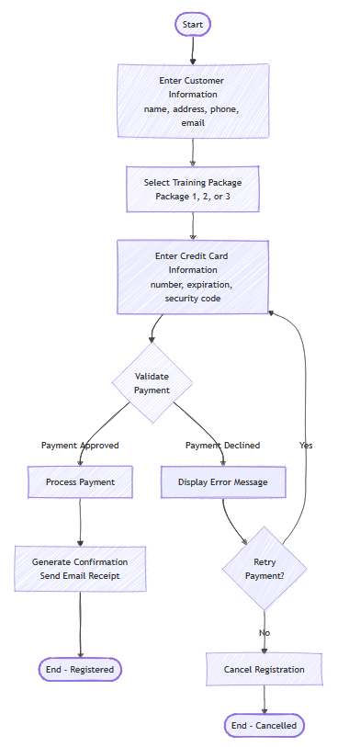
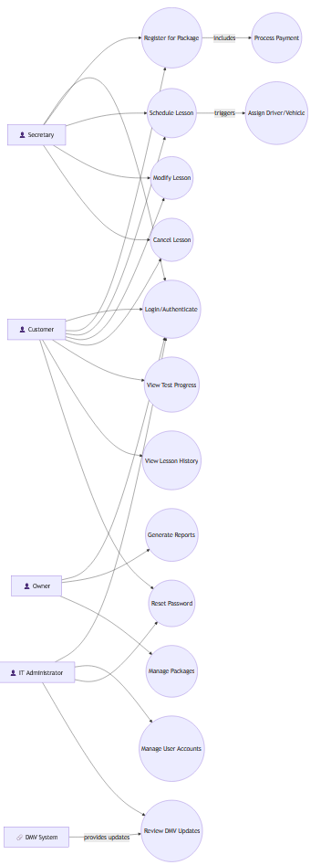
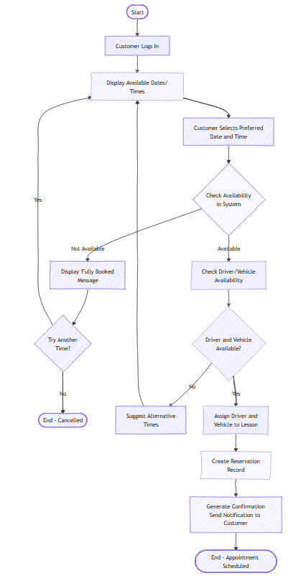
Figure 2-1: Activity - Register for Package
Figure 1: UML Case Diagram
Figure 2-2: Activity - Schedule Lesson
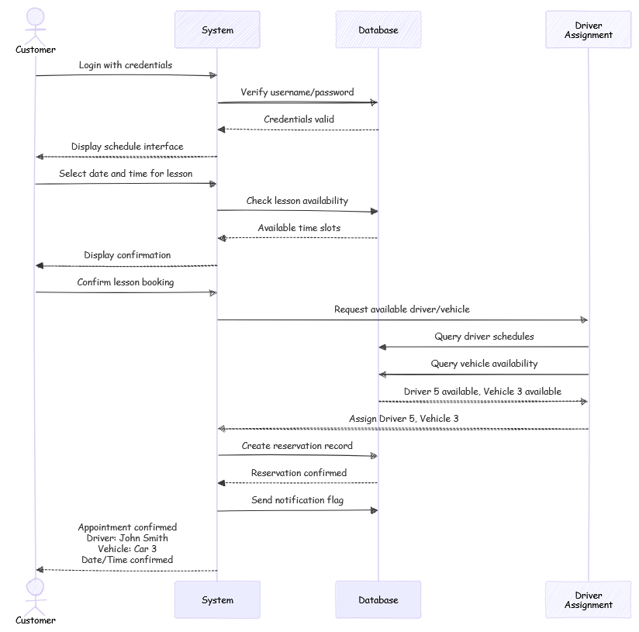
Figure 3: Sequence Diagram

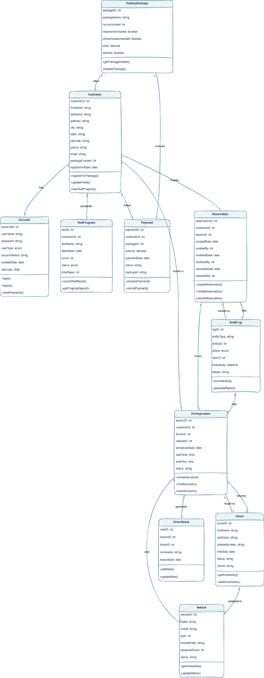
Figure 4: Class Diagram

